A theory of potential resonant-linking in family time

Christopher A. Tucker

**Keywords**

Family time, wave propagation. Family time applied to the mathematical representation of two propagating planar waves.

**Introduction**

The concept of wireless power transfer has been investigated intensively the past few years for large diameter coils in small and large power ratios over short and medium distances. The primary aim has been to reexamine a body of work which took place over the period of 1895 to 1925 and 1960 to 1970 to understand what the ascertainable differences are between transmitting information (signaling) and power transfer, as related to applicable theories from electromagnetism, especially those of J. Clerk Maxwell. What has been curiously absent from the discussion is how a circuit-antenna arrangement at the interface of free-space goes about coupling to long-distance circuits greater than three meters away and why potential linking is an important concept to achieve this. Regardless, an arbitrary stipulation has emerged that long-distance transmission is limited to an integer multiple of the transmitting coil’s radius. Along these lines, the various works have yielded a more-or-less uniform proposal of the transformative properties of a sinusoidal signal with large field magnitudes derived from Faraday. Classification of this phenomenon has been restricted to the near field and mid-range. In pursuing a solution to long-distance wireless power transmission, it would be ideal to find an arrangement that operates in both the mid-range and far field. One avenue has been the notion of manipulating magnetic field orders in electrically-short coils to increase coupling and the magnitude of potential linking. This paper will discuss such an arrangement of wireless power transfer at distances of ten meters using small scale coils.

**Family time**

The concept of family time in propagating electromagnetic waves , [1].

In the coupled mode, steady-state transmission and receiver circuits described in Fig. 1, we would like to describe the sinusoidal magnitude as a function of distance for the projected field, B taking the form of intersecting planar waves exchanged with a force, f, between the transmitter projecting the waves and feedback from the receiver circuit.

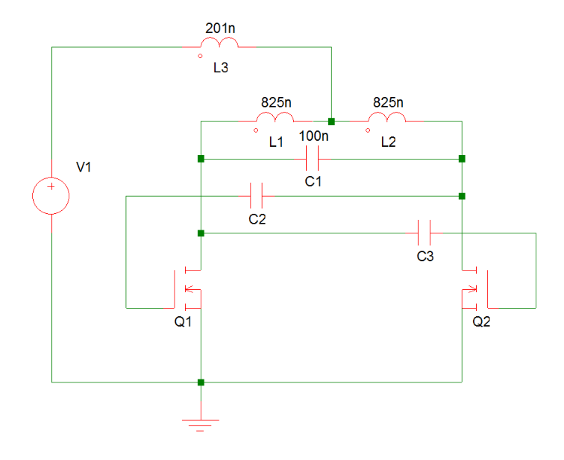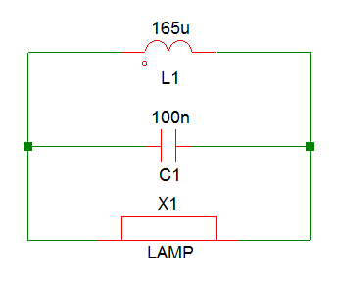165u?

Fig. 1. Left: transmission circuit; Right: receiver circuit.

The circuit represented in Fig. 1 has a sinusoidal frequency of 550 kHz with an input at V1 of 5 volts, 1 ampere.

Transliterate from the black book [1], pp. 216-30.

**Potential linking**

A time-varying current in a coil of wire induces an alternating magnetic field at right angles to it whose dynamics follow the curvature along the surface at the aperture. For a loop coil impressed with a current,  the energy,  as a summation of the forces form a radiation field with a hyperbolic structural pattern. If the forces responsible for the magnetic field oscillate at a sufficiently low frequency, it is possible to accurately model them in a quasi-static context [30]. As such, the forces appear as energy in the form,



where  and  are the forces in the plane  given the radius of the coil,  and the angle of the field,  relative to the surface of the conductive material. Lenz’s law states that the direction of the induced current is such as to oppose the applied current producing it. Given the material of the disc and its thickness, the eddy current takes the form of a polarization of the medium. The motion of the force of polarization is a vortex disturbance in the form of rotating conic sections converging to a point demarcated by the potential link [31]. The eddy current,  is given by



where  is the radius and  is the velocity of the field  Generally speaking, eddy currents flow in closed loops within conductors, in planes perpendicular to the magnetic field. The energy stored in the electromagnetic field is confined within a boundary,  given the projection of the zero order electrical,  and first order magnetic,  fields [32], as,



The first integral accounts for the rate of change of energy density of the electromagnetic field in the volume  the second integral energy dissipation, the third integral resonant energy by the input voltage, and the last integral the intensity of flow on the surface,  of the Poynting vector.  The total magnetic field energy,  inside the volume  equal to the stored energy in the circuital elements  and  is,



where the average stored magnetic energy at resonance in the transmitter circuit is,



Considering the non-neuronal organic tissue as a periodic structure in an off-resonant state [33, 34] with implicit time-dependence  that have the spatial dependences  and  due to the electrical potential of the field, respectively where  are propagation constants due to the strength of the link. For a period,  due to the frequency of the oscillator and the feedback dampening of the neural tissues, the coupling coefficient takes the form 

**Resonant-potential linking by inductance in time**

The linking model, an extension of coupled modes [33, 35-39], in a low-frequency application, is formulated around the strength of the potential field between the coil-oscillator combination as transmitter and coil-load receivers, in the circuital form given in [25].

The coupling coefficient of the form  for a period,  due to the frequency of the oscillator and the feedback dampening of the receiver. When  is transliterated to for a value of and  the plot of each step of *z* is shown in Fig. 86.

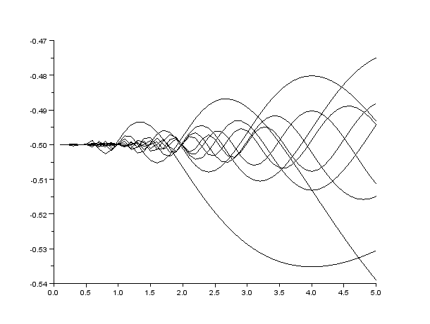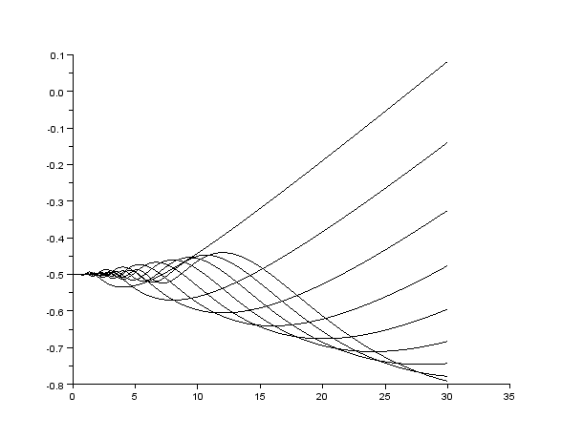

Fig. 2. Potential linking of the function  LEFT: over time and space  RIGHT: over time and space 

The plot in Fig. 2 is generated in Scilab with the following code. Note to start with high values for z then stepping lower.

function **dx**=f(**t**, **x**)

**dx**=2*0.014*cos(2*%pi*1/**t**)

endfunction

z = 1:1:10;

t0 = 0.1

x0 = -0.5

t = 0.1:0.1:5;

x = ode(x0, t0, t, f);

plot2d(t,x)

Note that in this code, *z* has to be entered manually and each plot drawn sequentially upon the other.

1159: From inspection of the plot, it seems this is the behavior I am looking for which describes a (force) responsible for resonant linking between two objects. Over large values of time, it would appear as, represented in Fig. 3. Note there is an angle of theta implied in the direction of the link.

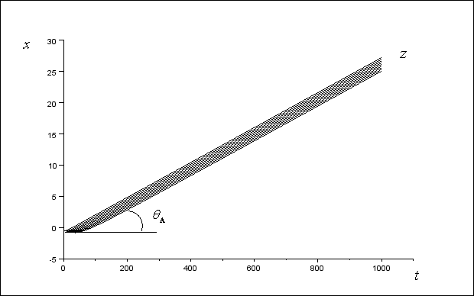

Fig. 3. Potential linking of the function  over time and space 

Therefore, the spatial equations are,



given a with a weak time dependence of amplitudes  and  because the link is passive,



relative to the coupled steady-state,



Where the utilized energy is given by the energy transferred to the receiving elements… by the conductance potential.

The definition of inductance, a primary feature of linking, revolves around a semi-classical interpretation that it does not exist purely for its own sake, rather, due to a tension between two resonant objects which, by a favorable geometric arrangement, are in near enough proximity to be considered coupled. The quantities required for potential linking and those representing its effect are the coupled force,  the potential of the field,  its displacement,  and the current density,  The absorption taking place at a dielectric axon has the quantities of consequential electricity parallel to it at in terms of its electrical properties from , cumulate to  as,



The force of the link is dependent upon the capacitance,  of the ions in the axon and its connective length, and the mutual inductance between the coil and somata, 



given the consideration of momentum at any point in the field over the length of the axon connectivity in the plane, 



related to the magnetic intensity, first from the magnetic force from the device,



It is well-known the motion of a magnetic pole in the electromagnetic field in a closed circuit cannot generate work unless the circuit which the pole describes passes around via electric current. Hence, except in the space occupied by the electric currents,



describes a differential of the scalar potential,  When in the proximity of the current  completely around the circuit  yields,



which is Maxwell’s equation of currents, contextualized here for the axon and glial cells of the neuronal somata. Therefore, the displacement force,  acting on the axon and glial cells, demarcated as an element of length,  in proximity to the magnetic field is



When an electromotive force acts upon a dielectric, the dielectric’s state is transformed into a polarized condition where currents oscillate along its length. A feedback force reflects energy back upon the potential link. The link is related closely to the formalism fordescribed by the geometry of moving forces within the magnetic field. Consequently, it is more relevant to discuss the potential link as a vector decomposition for the time-harmonic case, where the changing magnetic field induces electrical currents in the metallic disc,



over the neuronal somata,  where  is the permeability of the vacuum,  the relative permeability of the organic tissues lying on the path of the field,  the electric conductivity of the tissues, and  the voltage contained in the primary circuit. The magnitude of the potential link, is defined by the inductance properties of the circuit and of the neuronal somata coupled to the circuit via the link. The potential link is related to the solution for the vector potential, expressed in terms of the geometry of the motion at the disc, e.g., a line integral over the region encompassed by the disc of the parametric form  where *r* is the radius of the area under the loop. For the case of a current point-source where charges are manifest in the eddy currents as point-vortices, is derived in terms of the potential between the boundary of the coil and the area immediately under it, and between this area and the distance to the first neural tissues. The displacement of energy from the electromagnetic forces form a contour to the limit at the dispersion of the field as oscillating ordered fields described mathematically by family time [40],



where  The eddy currents coupled to the somata take the form a current density because of the assumption of a contour, the propagation of the eddy currents as collections of potential vortices,



and this value is taken to be -0.0002820196456 V*s/m when *r* = 2.5 cm. The total electromagnetic force acting on region of this space Ω can be obtained by integrating Maxwell’s stress tensor and the Larmor force on the delimiting boundary ∂Ω,



**Conclusions**

Words.

**References**

1. R.M. Fano, L.J. Chu, and R.B. Adler, *Electromagnetic fields, energy, and forces*, MIT Press, 1968.
2. z